READ ME

1) Please unzip the folder

2) Open VertMarkets sln file using Visual studio 2017(I have developed using Visual studio 2017 I would prefer to open project in Visual studio 17 or 19).

3) Before Clicking the run button on Visual studio make sure Project language Version is c#7.3( You can check right click on VertMarkets sln file in solution Explorer and click on Build and check the version)

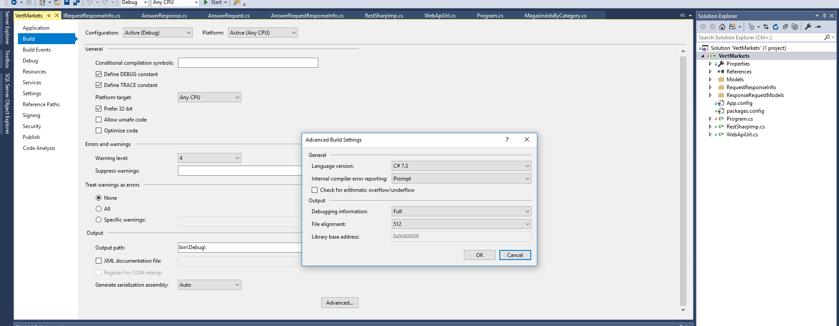

4) Click On Start Button in Visual studio to show you the output on the console screen.